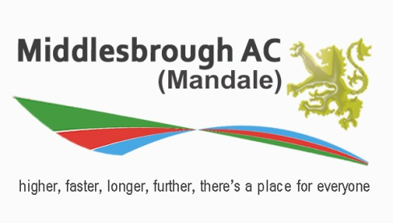
CLUB PROPOSAL FORM 2023

Proposed amendments to club rules Part 1 and positions up for election Part 2 will be presented during the AGM on Thursday, November 9th, 2023.
It is scheduled to convene at 7:30 p.m in The Training Room, located upstairs at Middlesbrough Sports Village.

Submissions of proposals should be made prior to the Annual General Meeting. To formally declare your candidacy for any available positions, please complete the form below and forward it via electronic mail by Midnight on November 1st, 2023 to: . middlesbroughmandale_events@outlook.com

Please be advised that only applications submitted using this form will be considered. To qualify for committee positions, applicants must hold a membership in the Club and commit to attending Committee meetings. Proposal forms received after the closing date will not be accepted. Voting during the Annual General Meeting will occur only if there are multiple candidates running for a position. If any position remains unfilled, proposals from the floor will then be sought.

Part 1
Proposal to add or change a club rule:

Please now sign and date this form at the bottom of this page

Part 2
I wish to stand for the following position (please indicate with an X)

Name _____________________________________

Committee positions
Chairperson |  | Development Officer
 |  | School Liaison Officer
Treasurer |  | Team Manager-Cross Country
Secretary |  | Team Manager- Senior Men’s/Ladies Track & Field
Membership Secretary |  | Team Manager- NEYDL U13/U15/U17/U20 Track & Field
Welfare Officer (male) |  | Fundraising
Welfare Officer (female) |  | Merchandising

Signed _____________________________ Date ______________________

Supported by _________________________ Signed _____________________
(Must be a current Club member)

Please send responses to: middlesbroughmandale_events@outlook.com

