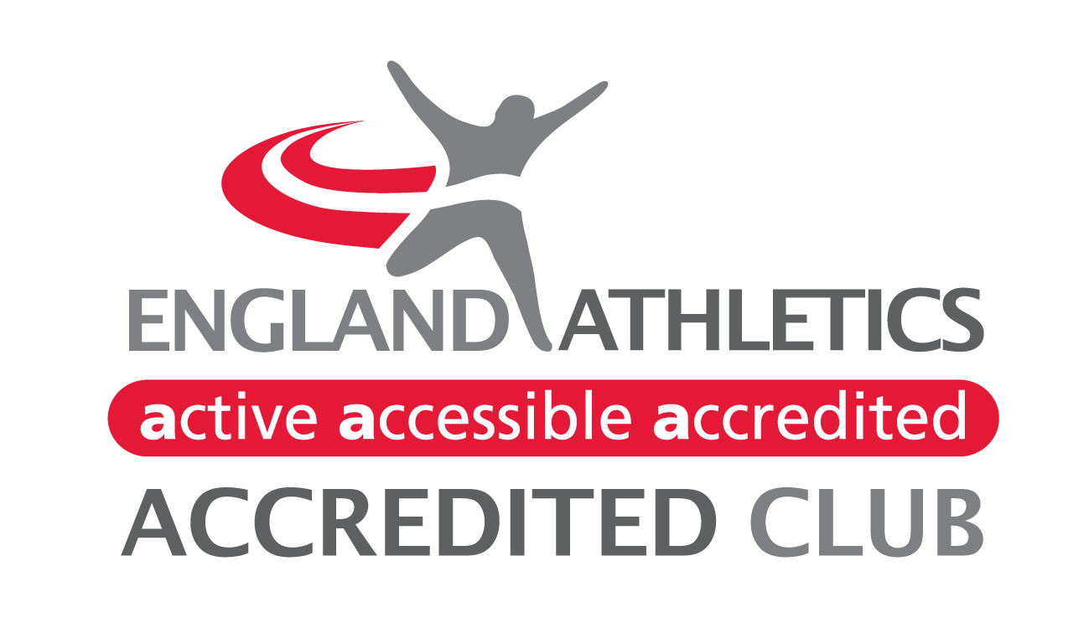
Welcome to Middlesbrough (Mandale). We are an athletic club open to athletes of any ability from eight years of age. Please complete the 3 pages and return to the Membership Secretary, contact details below.

For details of all club activities and coaching groups, please visit www.middlesbroughac.org.uk

SUBSCRIPTION FEES The membership year runs from 1st February to 31st January annually.
Sticking to 2020 Prices!
Over 17: £50.00 Under 17/Student/Unemployed: £40.00 Under 11: £20.00
Affiliate non-competitive member/ Volunteer/Coach/Official: £0.00
Athletes wishing to add Mandale as a Second Claim, please contact directly (details below)
Cheques, payable to: MIDDLESBROUGH AC (MANDALE)
BACS:
Account Name: Middlesbrough AC (Mandale)
Account Number: 12552475
Sort Code: 05-09-50
Bank: Yorkshire Bank (Virgin Money)
Please reference all payments Surname, Forename of the Athlete.
All those wishing to become members, even volunteers must please complete this form.

Membership Benefits:
- Free Coaching and training advice from qualified, experienced and DBS checked coaches.
- For competing athletes fee also includes £16.00 payment to England Athletics and £2 to Northern Athletics for your Competition registration.

Athletes are required, if selected, to compete for the club

Club colours must be worn in all competitions unless Under 11, in which case a plain t-shirt can be worn. Vests can be purchased via our Club shop on the website www.middlesbroughac.org.uk.

CLUB HEADQUARTERS
Middlesbrough Sports Village, Alan Peacock Way Middlesbrough TS4 3AE
03000 4560550

Membership Secretary:
Mrs Kate Brazukas, 14 Beacons Lane, Ingleby Barwick, Stockton on Tees, TS17 5EF
middlesbroughmandale_membership@outlook.com
20.12.2021

Middlesbrough Athletic Club (Mandale)
Membership Application Form
First Name(s) * |  |  |  |  | Title
Last Name * |  |  |  |  | Male or Female *
Address 1 |  |  |  |  | Date of birth *
Address 2 |  |  |  |  | Town
Postcode * |  |  |  |  | Place of Birth *
Date* |  |  |  |  | Coach
Contact
Home Phone |  |  |  |  | Mobile Phone (If over 16)
E-Mail of Parent/carer NOT athlete
Membership of other athletic clubs:
Other clubs of which you are a member |  | Status i.e. First/Second Claim |  |  |  |  |  | Date of resignation from previous club
Disciplines in which you are interested in: *
Cross Country | Fell & Trail |  | Road Running |  |  |  |  |  |  | Track & Field
Membership Status:
Competing | Coach |  |  | Volunteer |  |  | Social |  |  |  | Official
Ethnic Origin: White (UK/Euro/Non-Euro) Black (UK/AFR/Caribbean) Chinese
Mixed Indian Pakistani Bangladeshi

*Must be completed please
PLEASE COMPLETE all PAGES OF THIS FORM
Medical Information:
Please detail below any important medical information that our coaches/junior
co-ordinator should be aware of e.g. epilepsy, asthma, diabetes, allergies etc.
Please do not leave blank – if there is no information please write ‘None’.

Emergency Contact Details:
Contact 1 Name
Contact 1 Number
Contact 2 Name
Contact 2 Number
It may be essential at some time for authorised persons acting on behalf of the club to have the necessary authority to obtain urgent treatment which may be required whilst representing the club in training or competition.
Signature
PRINT NAME

Parent/Carer details: If you are under 17 please ask your parent/carer to complete this next section.
First Name |  | Surname
Address
Postcode |  | Mobile
Telephone
Email
Parent/Carer Help:
Please remember everyone within the club is an unpaid volunteer. Please tick the areas you may be interested in helping with. The club will contact you regarding this. If there is a specific area of expertise that you feel you can bring to the club, please indicate below.
Helping at athletic meetings |  | Assisting training
Refreshment area |  | Team Management
Fund raising |  | Committee post – contact Membership Secretary
Website management |  | Helping Officials
Promotion & Marketing
Other (please specify)
Athlete Agreement: (To be completed by all) by returning this completed form,
- I am willing to abide by the club code of conduct for athletes- on the website - and agree always to behave in a manner befitting a Middlesbrough Athletic Club Athlete when attending club events.
- I agree to compete for the club in team competition, if selected.
- I confirm I am eligible to compete under UK Athletics rules.
- I am, as far as I am aware, fit to take part in strenuous physical activity.
- I agree to the disclosure of my name and date of birth in a list of members to the EA.

Signature
PRINT NAME
Parent/Carer/Over 17/Under 17 Agreement: (to be completed by all)
By returning this completed form, I agree:
- To the named athlete taking part in the activities of the club.
- That I have read and agree to abide by the club code of conduct whenever I am present at club activities or competition.
- To help out at any club events.
Signature
PRINT NAME

Photography & Video Consent: (Those aged 18 and under)
Middlesbrough AC recognises the need to ensure the welfare and safety of all young people in athletics.
In accordance with the UK Athletics child protection policy and procedures, we will not permit photographs, video or other images of children/young people to be taken without the consent of parents/carers and children/young people.
The Club will take all possible steps to ensure these images are used solely for the purposes they are intended. If you become aware that these images are being used inappropriately, you should inform the Club welfare officer immediately.
The parent/carer……………………. consent to Middlesbrough AC (Mandale) or a photographer appointed by the club photographing or videoing my child’s involvement in athletics for the purposes of publicising and promoting the club or sport, or as a teaching aid.
Club Privacy Statement:
The Club takes the protection of the data that we hold about you as a member seriously and will do everything possible to ensure that data is collected, stored, processed, maintained, cleansed and retained in accordance with current and future UK data protection legislation.
Please read the full privacy notice carefully (found under Governance) to see how we will treat the personal information that you provide to us. We will take reasonable care to keep your information secure and to prevent any unauthorised access.
Data sharing with England Athletics:
When you become a member of or renew your membership with Middlesbrough AC (Mandale) if you are going to compete, you will be registered with and become a member of England Athletics. If you have any queries about the privacy of your personal date when shared with EA, please contact them dataprotection@englandathletics.org or discuss with the Membership Secretary.

We look forward to welcoming you and your family to the club in the near future. To find out all the latest club information, please visit our website
www.middlesbroughac.org.uk
Feel free to use this blank space to supply me with any relevant details or questions.

